**HR Analytics**

## **Overview**

This Power BI project focuses on HR analytics and aims to provide insights into various aspects of human resources within an organization. The dataset used for analysis contains several columns related to employee information as stated below.

## **Dataset**

The dataset used in this Power BI project contains the following columns:

EmpID: Employee ID

Age: Age of the employee

AgeGroup: Age group to which the employee belongs

Attrition: Employee attrition status (whether the employee has left the organization or is still active)

BusinessTravel: Frequency of business travel for the employee

DailyRate: Daily rate of pay for the employee

Department: Department in which the employee works

DistanceFromHome: Distance in miles from the employee's home to the workplace

Education: Level of education attained by the employee

EducationField: Field of education of the employee

EmployeeCount: Number of employees

EmployeeNumber: Unique identifier for each employee

EnvironmentSatisfaction: Employee's satisfaction level with the work environment

Gender: Gender of the employee

HourlyRate: Hourly rate of pay for the employee

JobInvolvement: Employee's level of job involvement

JobLevel: Level of the employee's job position

JobRole: Role of the employee within the organization

JobSatisfaction: Employee's satisfaction level with their job

MaritalStatus: Marital status of the employee

MonthlyIncome: Monthly income of the employee

SalarySlab: Categorization of monthly income into salary slabs

MonthlyRate: Monthly rate of pay for the employee

NumCompaniesWorked: Number of companies the employee has worked for in the past

Over18: Whether the employee is over 18 years old

OverTime: Whether the employee works overtime or not

PercentSalaryHike: Percentage increase in salary for the employee

PerformanceRating: Performance rating of the employee

RelationshipSatisfaction: Employee's satisfaction level with work relationships

StandardHours: Standard working hours for the employee

StockOptionLevel: Level of stock options granted to the employee

TotalWorkingYears: Total number of years the employee has worked

TrainingTimesLastYear: Number of training sessions attended by the employee in the last year

WorkLifeBalance: Employee's work-life balance satisfaction level

YearsAtCompany: Number of years the employee has worked at the current company

YearsInCurrentRole: Number of years the employee has been in the current role

YearsSinceLastPromotion: Number of years since the employee's last promotion

YearsWithCurrManager: Number of years the employee has been working with the current manager.

## **Business Task:**

The stake holders are interested in seeing the attrition rate and need recommendations to reduce the attrition and maintain healthy employees.

### **Prepare:**

**Data Location and Organization:**

I've downloaded the HR Analytics data set which contains contents of 1480 employees.

I would like to thank Kaggle for providing the dataset.

**Problems with the Data**:

The only problem with the data is it has 7 duplicate rows. Since the data is small I prefer to clean data with Excel.

### **Process**:

I have created two new calculated columns attrition count and overtime count. I have also created a measure for Attrition %.

### **Analyze**:

**Trends**:

We have a total employee count of 1473 with an attrition rate 16.09%

We have 60% males and 40% female working employees.

The maximum age category who resigns is 26-35. Single Middle age people are the most reason for attrition.

Research and development department has the highest employee count for attrition.

Job satisfaction rating holds a positive relation with Attrition rate. Employee voted rating 1 leaves the company most.

## **Share:**

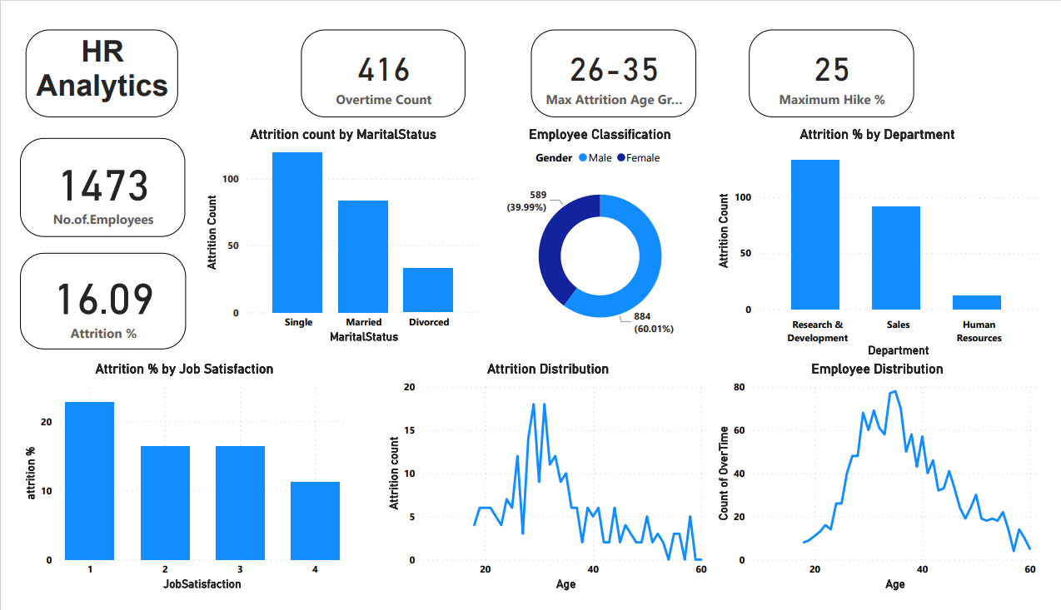

## **Recommendations:**

* Promote a healthy work-life balance.
* Recognize and reward employees for their contributions.
* Provide clear paths for career growth and development within the organization.
* Regularly conduct exit interviews to understand the reasons behind employee departures.
* Ensure that the workplace is conducive to productivity and well-being.
* Monitor and address excessive workloads that can lead to stress and burnout.
* Create a diverse and inclusive workplace.